PHASE 6 – DOCKER COMPOSE PRACTICAL
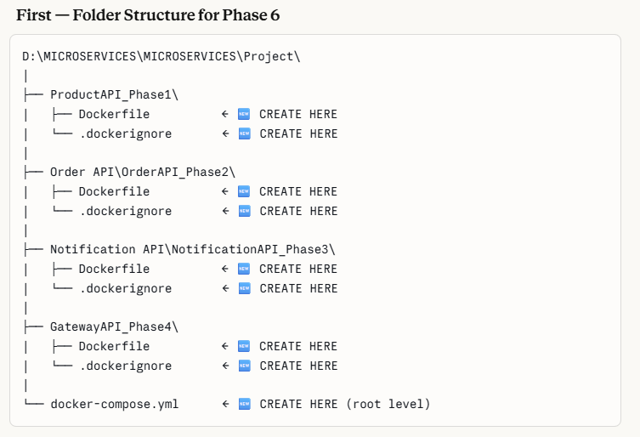
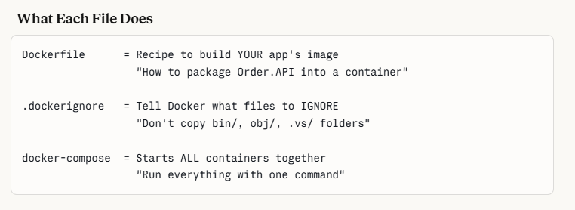
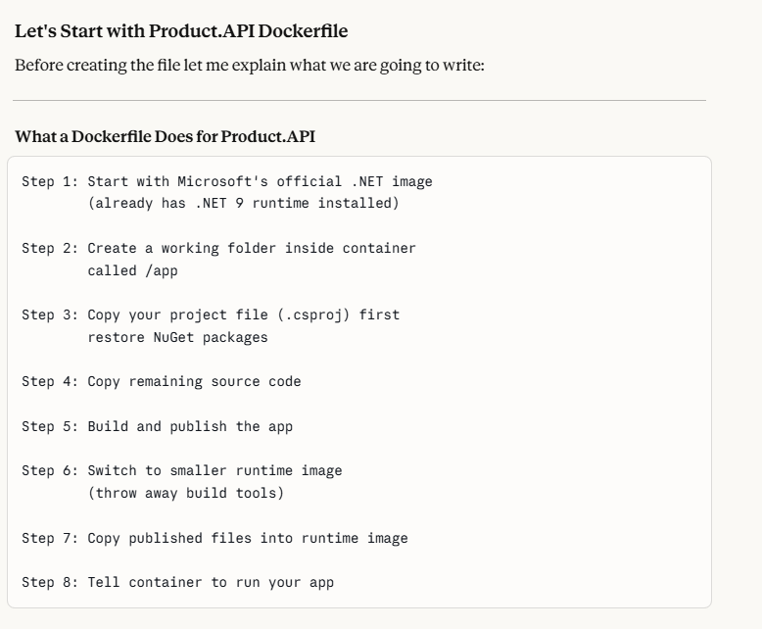
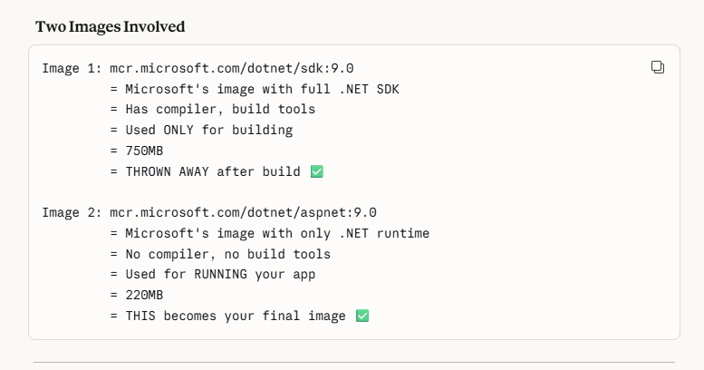
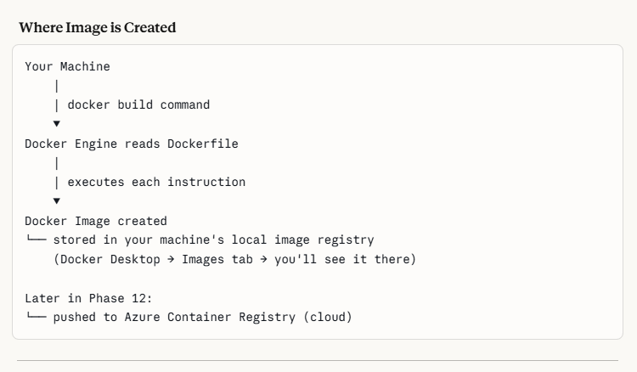
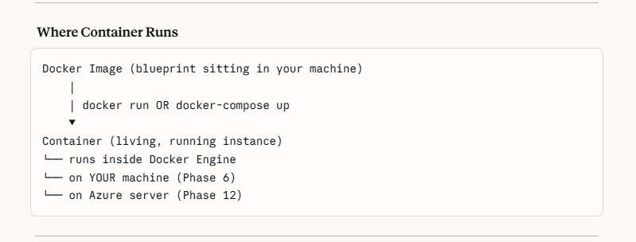
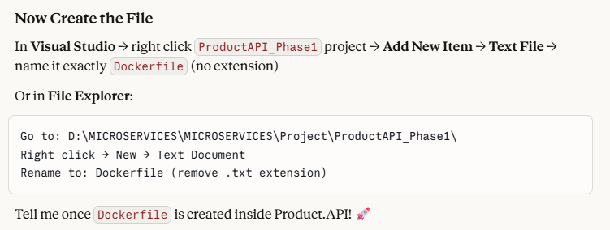

Why Separate Dockerfile for Each?
Because each API is a separate application:
Product.API → its own code → its own image → its own container
Order.API → its own code → its own image → its own container
Notification → its own code → its own image → its own container
Gateway → its own code → its own image → its own container
CONDITIONS FOR WRITING DOCKER FILE
Rule 1 — Dockerfile must be in same folder as .csproj
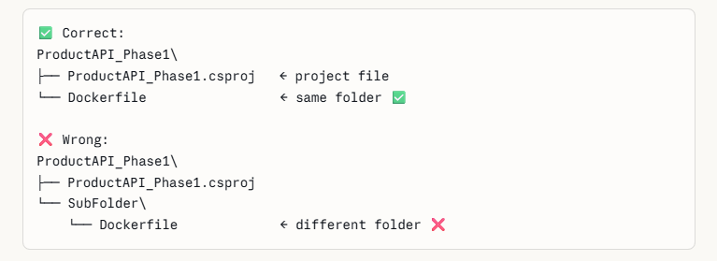
Rule 2 — Filename must be exactly Dockerfile
✅ Dockerfile ← correct (no extension, capital D)
❌ dockerfile ← wrong (lowercase d)
❌ Dockerfile.txt ← wrong (has extension)
❌ MyDockerfile ← wrong (different name)

Rule 3 — Each Dockerfile is independent

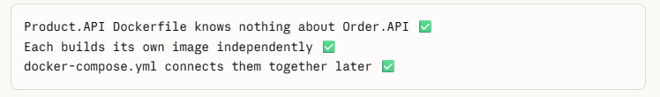
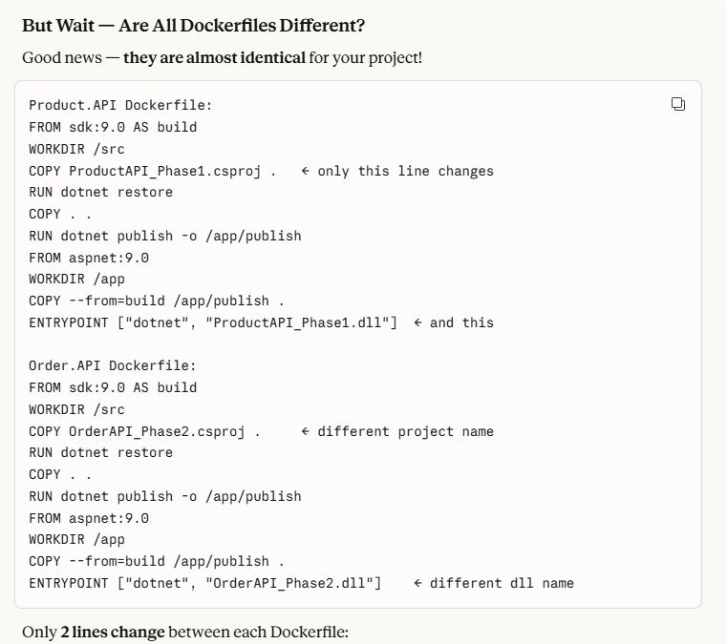

Q: What is a DLL in .NET?
A: DLL is a compiled output of your .NET project.
When you build/publish a C# project, the compiler
convert your source code into a DLL file.
The .NET runtime executes this DLL.
It contains compiled IL (Intermediate Language) code
which the CLR (Common Language Runtime) executes.

Q: Why do we use DLL in Docker?
A: In Docker we publish the compiled DLL, not source code.
This is more secure (no source code exposed),
faster to start, and optimized for production.

Q: What is a multi-stage build in Docker?
A: Multi-stage build uses multiple FROM instructions. First stage uses full SDK to compile the app. Second stage uses lightweight runtime image. Only compiled output is copied to final image. Result: smaller, secure production image without source code or build tools exposed.

Q: Why separate build and runtime stages?
A: SDK image is 750MB, runtime is 220MB. Multi-stage gives us: ├── Smaller final image (faster deployment) ├── No build tools in production (more secure) ├── No source code in production image (more secure) └── Faster container startup

Q: What does ENTRYPOINT do?
A: ENTRYPOINT defines the main command that runs when container starts. It's the process that keeps the container alive. If ENTRYPOINT exits, container stops.

Q: Difference between RUN and ENTRYPOINT?
A: RUN executes during IMAGE BUILD time e.g., installing packages, compiling code ENTRYPOINT executes when CONTAINER STARTS e.g., starting your application

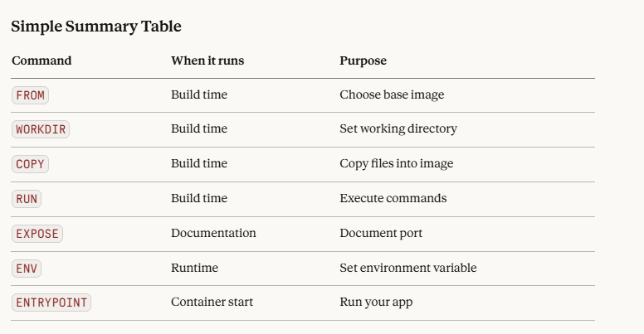

Q: What is the difference between SDK and Runtime image?
A: SDK image contains the full .NET development toolkit including compiler, build tools, and dotnet CLI. It's used during the BUILD stage to compile code. Size is ~750MB.
Runtime image contains only what's needed to EXECUTE a compiled .NET application. No compiler or build tools. Size is ~220MB. Best practice is multi-stage build: Use SDK to compile → copy DLL → use Runtime to run. Result is smaller, more secure production image.

Best practice is multi-stage build: Use SDK to compile → copy DLL → use Runtime to run. Result is smaller, more secure production image.
SDK Image = Full workshop with all tools (build here) ASP.NET Image = Clean empty room with just electricity (run here) 🏃 Base Runtime = Same but no ASP.NET (for console apps only)

Next is to create a .dockerignore File

Create a new file named .dockerignore inside ProductAPI_Phase1 folder.

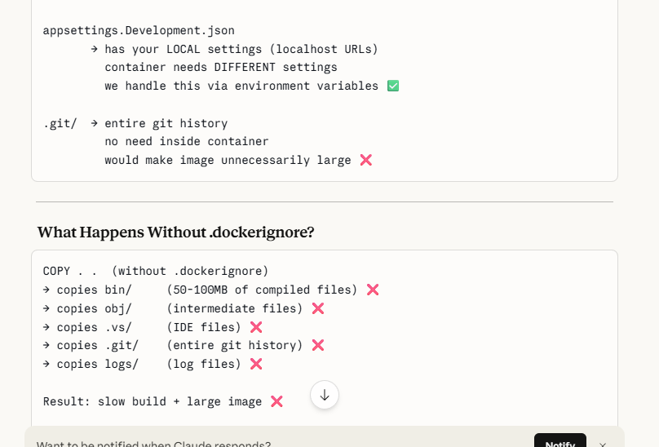

Likewise , Create the same docker file and .dockerignore in all api’s, like order.api, notification etc
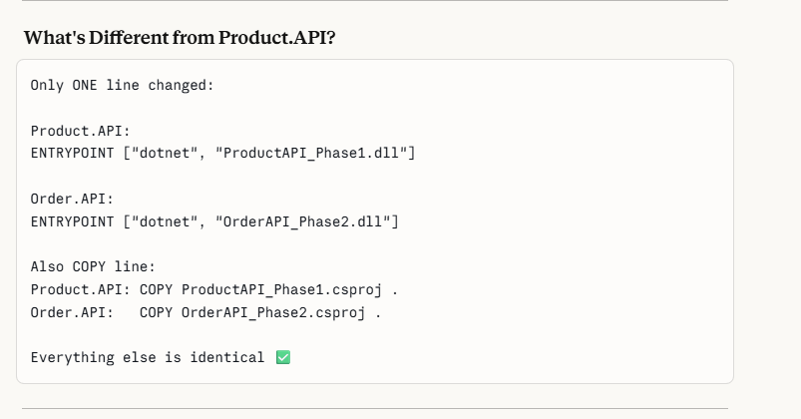

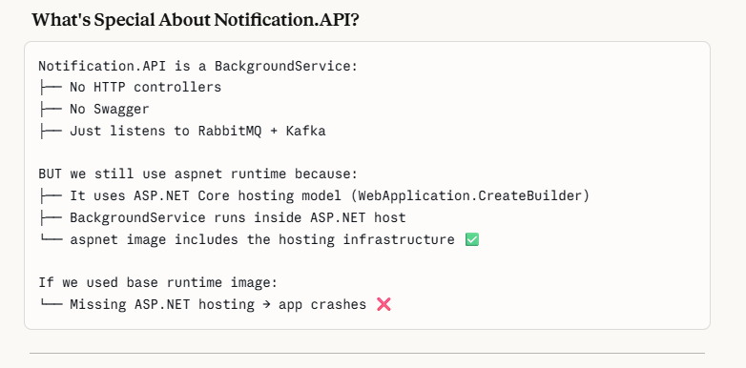

Check whether all the dockerfiles and the docker ignore have been created in all aPI
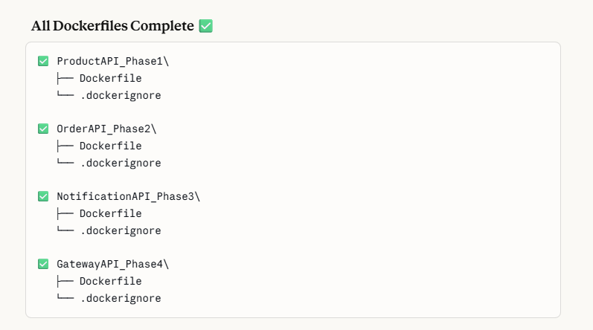
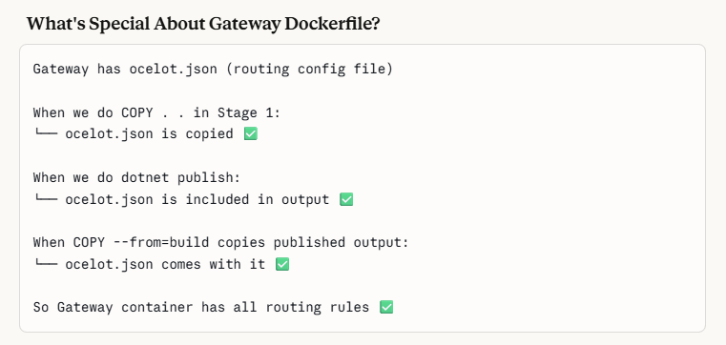

DOCKER COMPOSE - YML

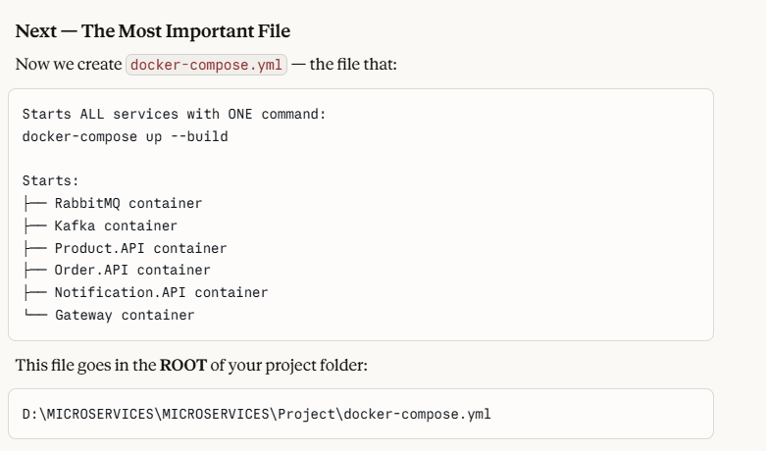

Notes of the Docker-compose.yml file which we created(refer the script part)

It is very important to know about the docker compose file

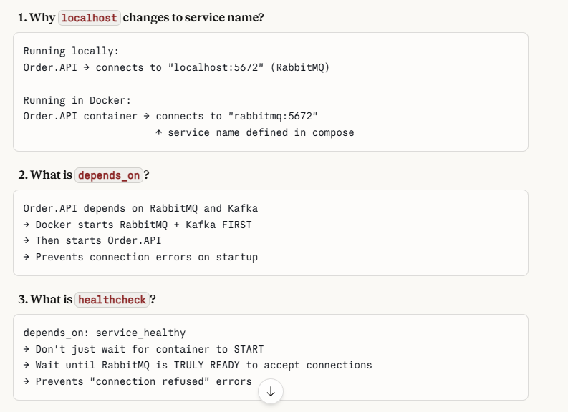
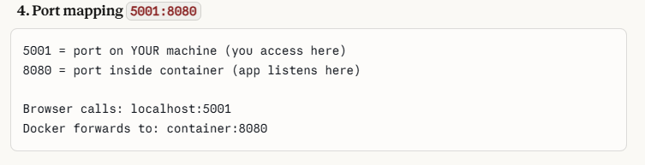
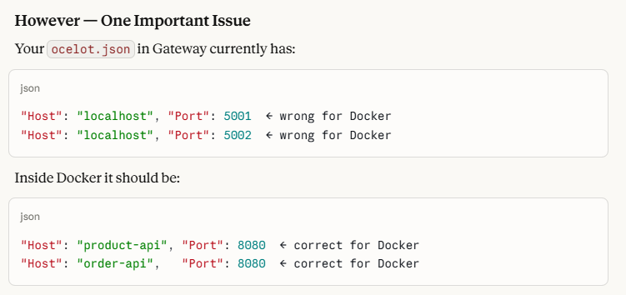

Question : But you said ,when we run the application, the local host runs on 5001 through the gateway, and when it runs in docker ,the docker forwards it to the port 8080, in that case why we need to change the ocelot.json in the gateway api

WORKING ANALOGY OF THE DOCKER AND GATEWAY , HOW THE API’S EXECUTS AND RUN INSIDE THE DOCKER

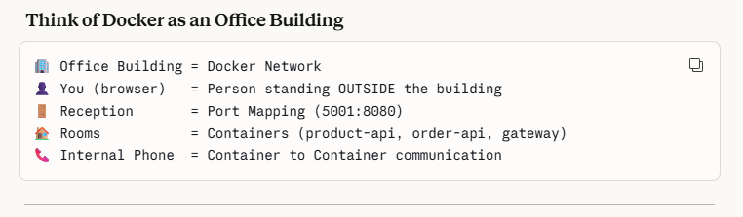
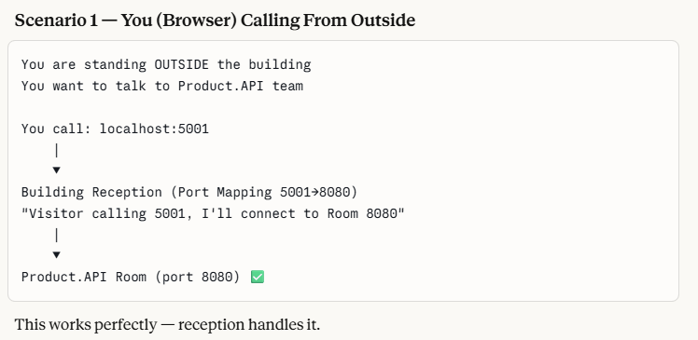
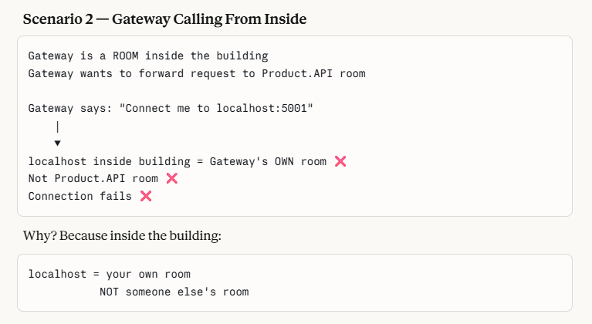
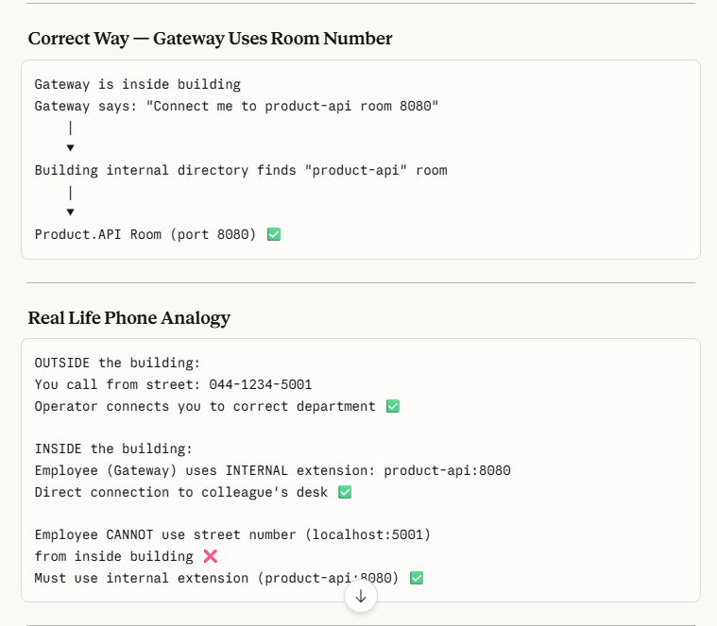
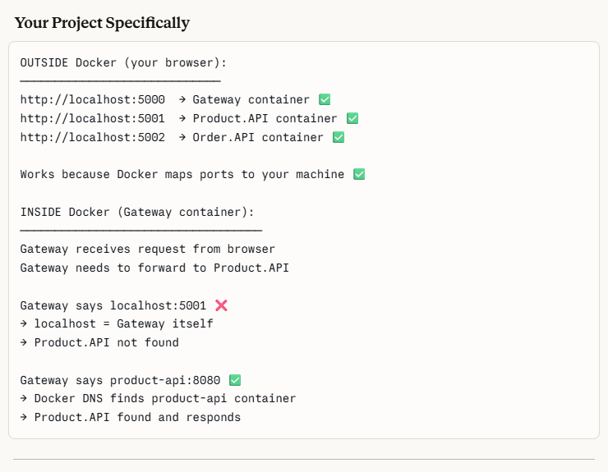

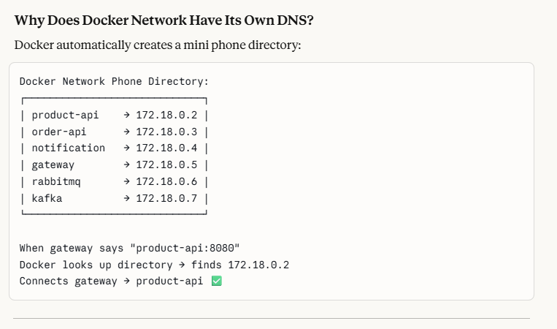
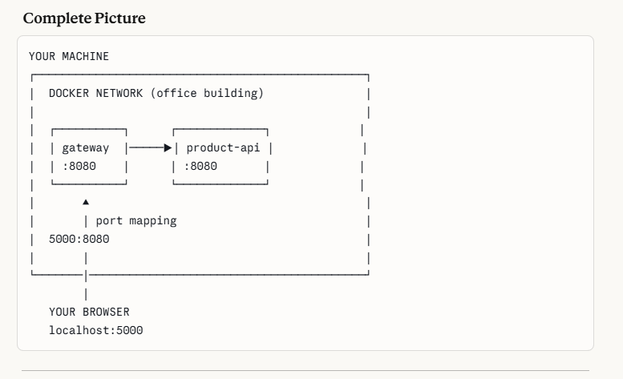
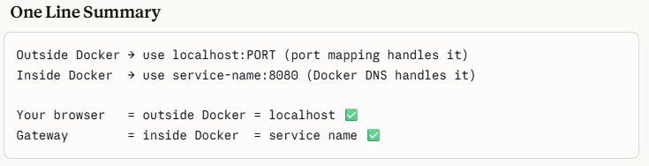
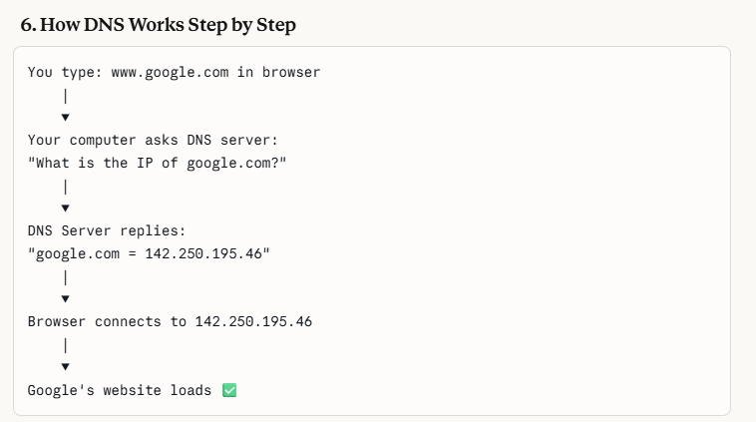
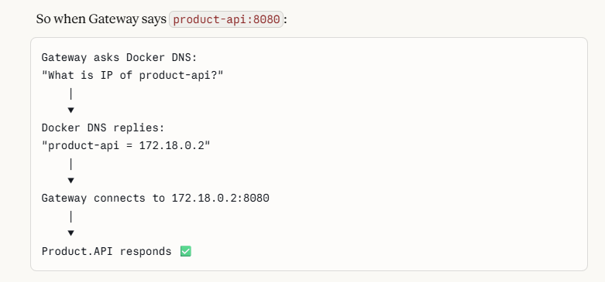

Docker creates a mini DNS inside its network.

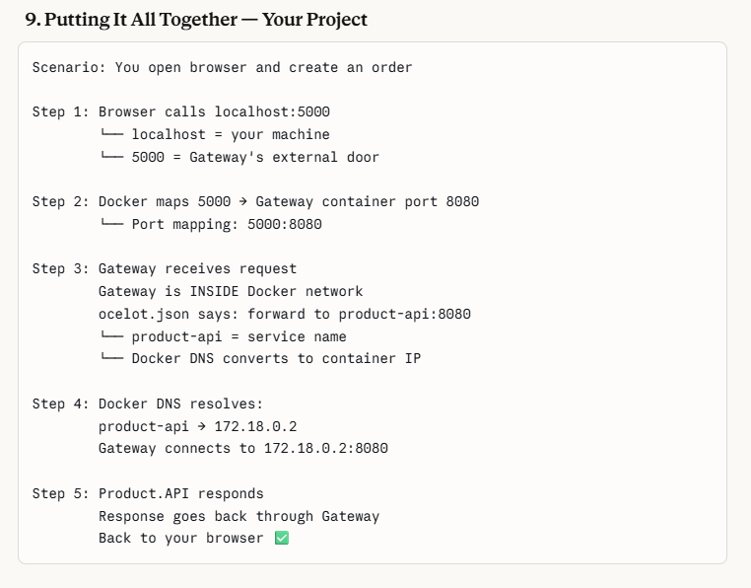
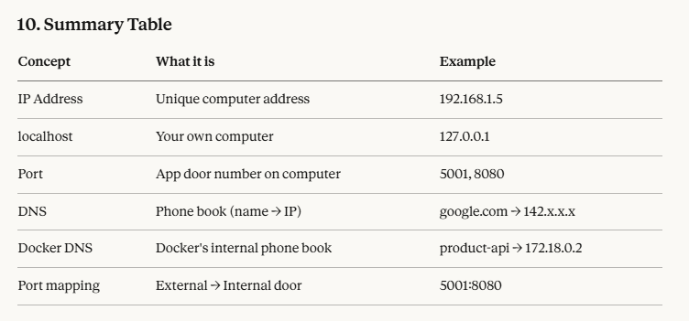
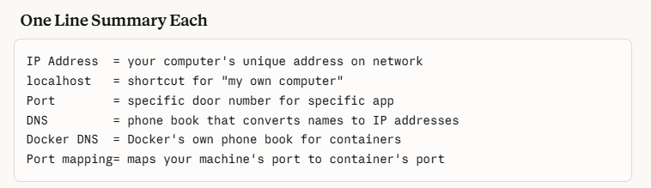

NEXT CREATE COCELOT.DOCKER.JSON – IN GATWAY API PHASE4 – TO MAP THE PORTS

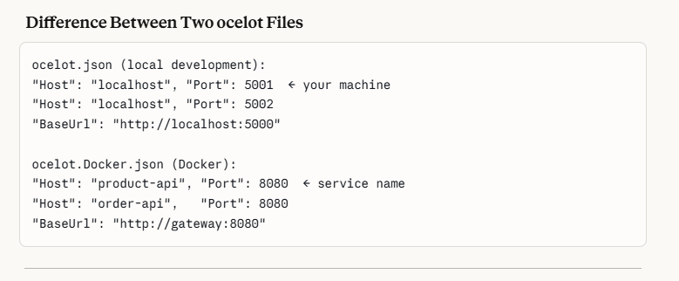

Next - We need to tell Gateway: "load ocelot.Docker.json when running in Docker"
Open GatewayAPI_Phase4/Program.cs and replace with this: (replace the existing code in the program.cs) , as we are containerizing the application, we must alter the things , so that it runs correctly in the docker

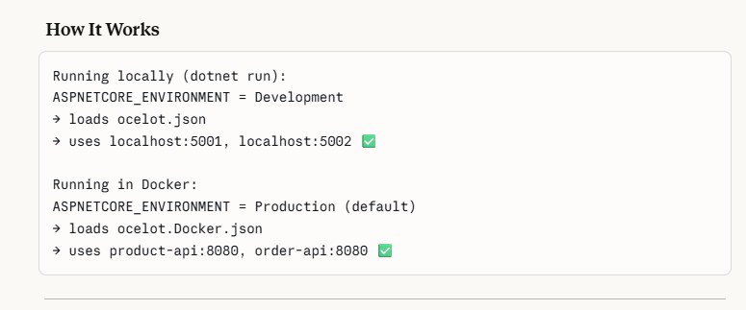

Next – update the order.api – appsettings.json :
When running in Docker, Order.API calls Product.API using service name. We handle this via environment variables in docker-compose.yml already — but let's also update Program.cs in Order.API to read the ProductAPI:BaseUrl correctly.

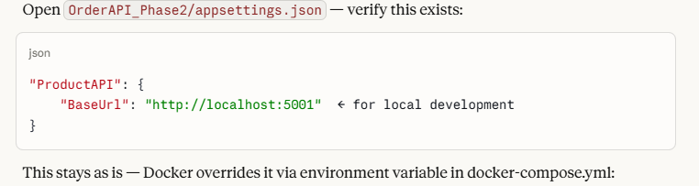

Inside the Docker-compose file we have to mention the exact path names, that is where our project is exactly located. If this is given wrong then there wont be proper connections
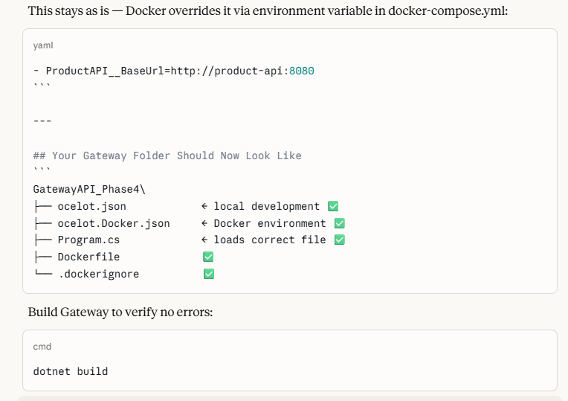
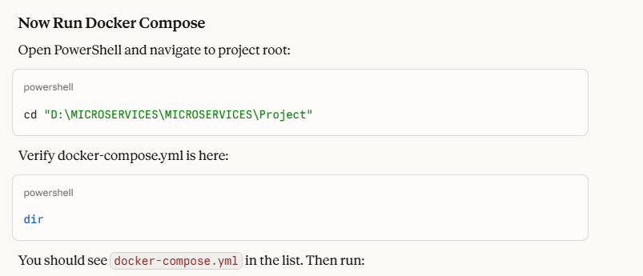
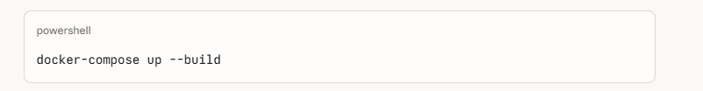
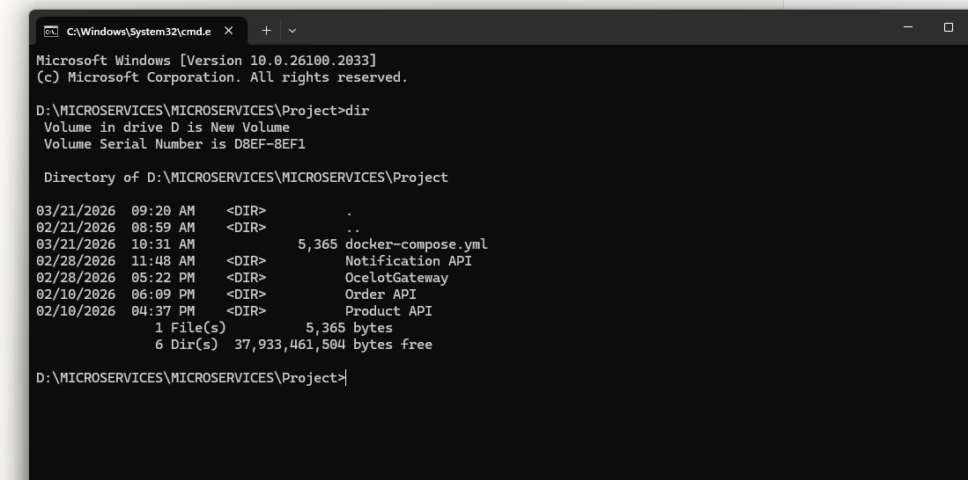

After checking the directory structure, give the docker compose build.- check in the directory structure whether you get the docker-compose.yml, after checking you can give the build

docker-compose up –build – here what happens is Docker starts building the images of all the 4 API’s

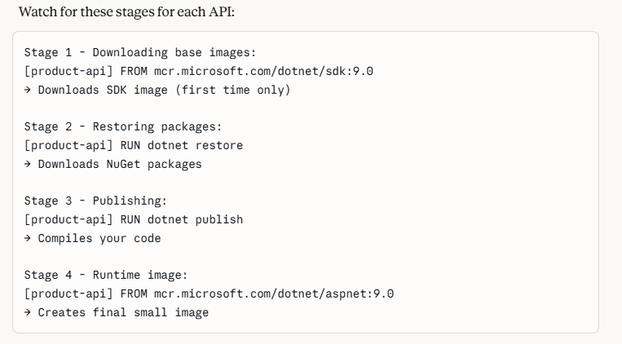
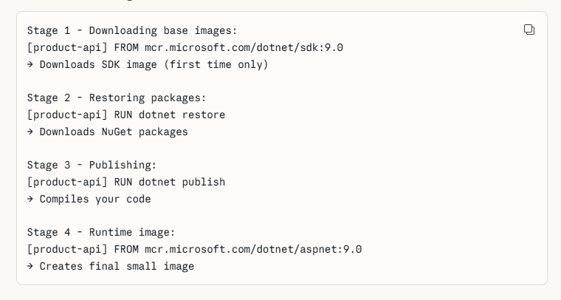

If you get Kafka and rabbit mq running separately in docker, when you build the docker compose , you will be getting the conflict error

Fix — Remove Existing Containers (run the below commands)

docker stop kafka
docker stop rabbitmq
docker rm kafka -------------- this is used to remove the kafka inside the docker desktop which was running earlier

docker rm rabbitmq

After removing the rabbit mq and kafka, run the docker compose again –
“docker-compose up” (no need of using –build this time, because images are already built)

Once you have run the docker-compose in the command prompt, you will be getting the below screenshot, which shows the “Project” container keeps running in the docker desktop. This project is the container which holds all the api’s and the gateway, rabbit, kafka composed in a single container – so this is the advantage of the Docker (it containerizes everything ) – now this app can be deployed anywhere

In the 2nd screenshot – you can see the images that are built for separate API’s , , for this you have to click the project and view the api’s running (this is the whole container)
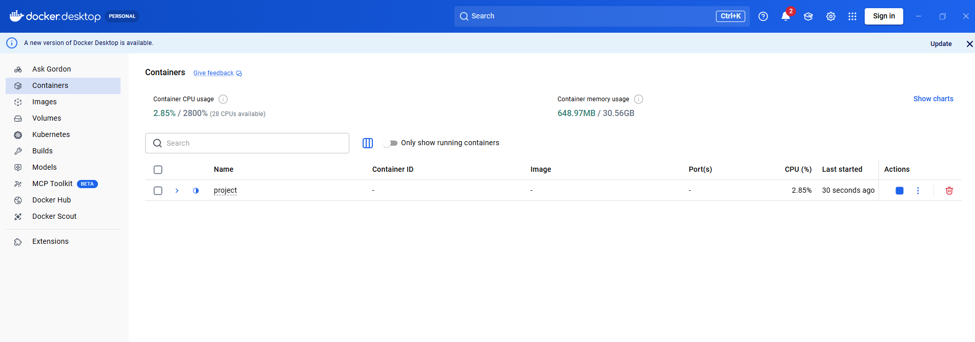
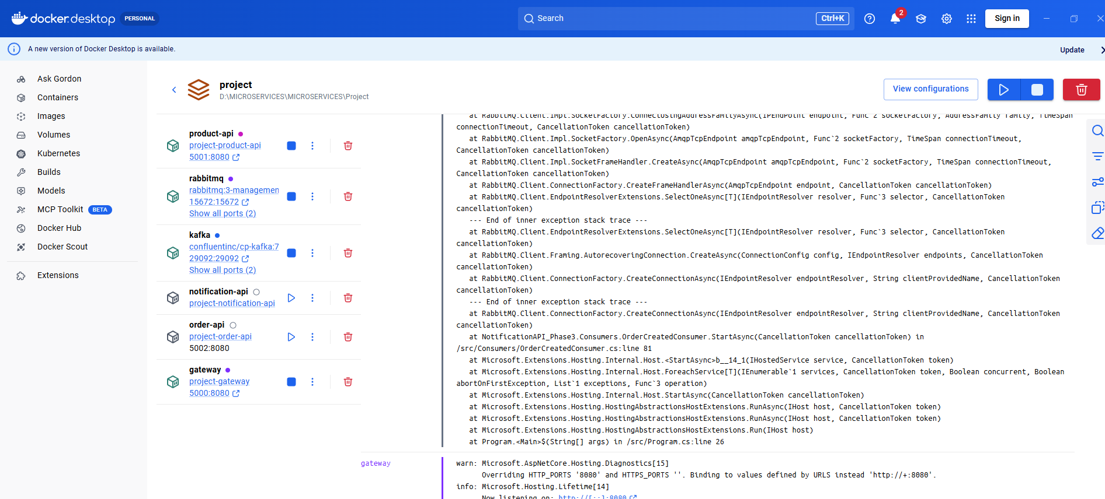

------------------------ IMPORTANT SCENARIOS----------

1.if i want to change the container name "E-commerce App" instead of Project what shall i do
- Now I want to develop a new module like invoice bills - in that case how can i include it here in the container

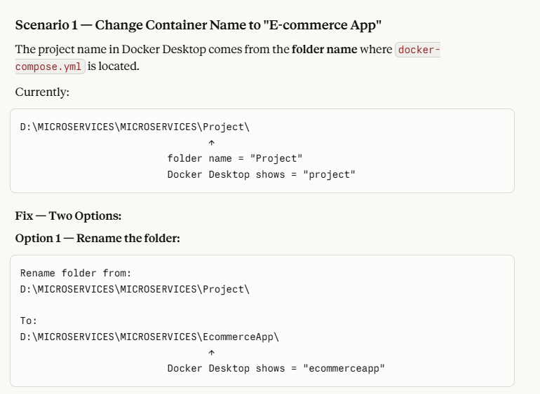

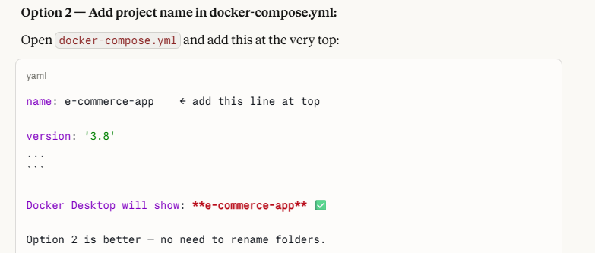

REFER BELOW THE SCENARIO WHERE YOU CAN ADD ADDITIONAL MODULES
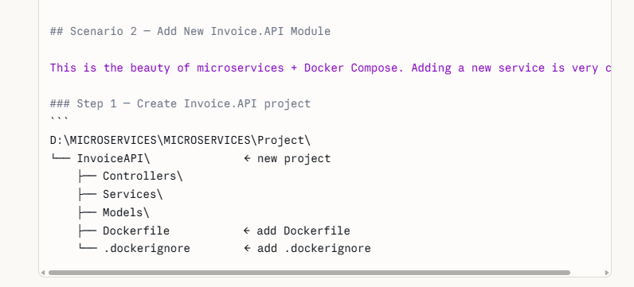
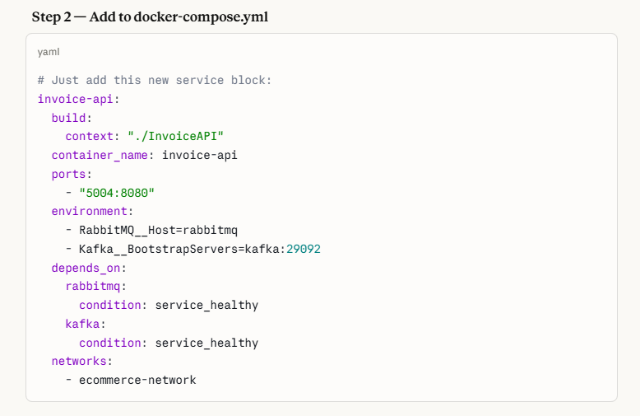
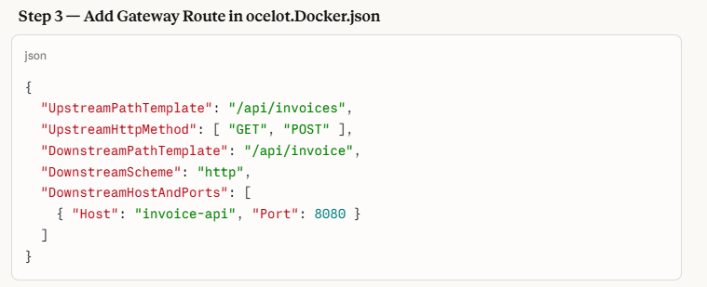
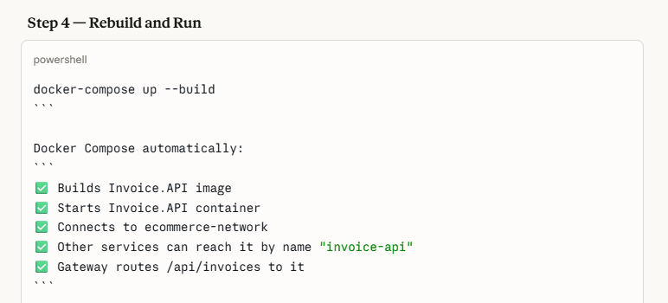
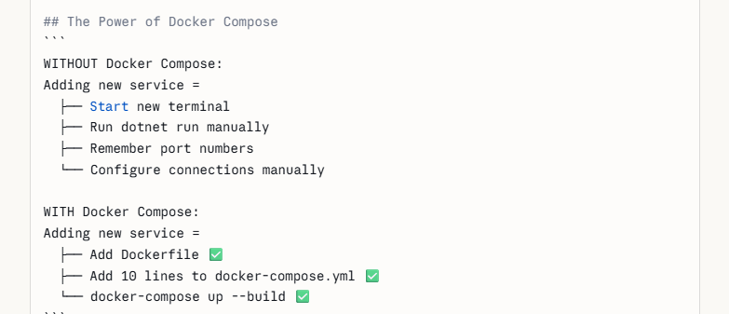

------------------NEXT----------------- IMPORTANT – TEST ALL THE SERVICES RUNNING IN DOCKER-----

- Open your browser and test one by one
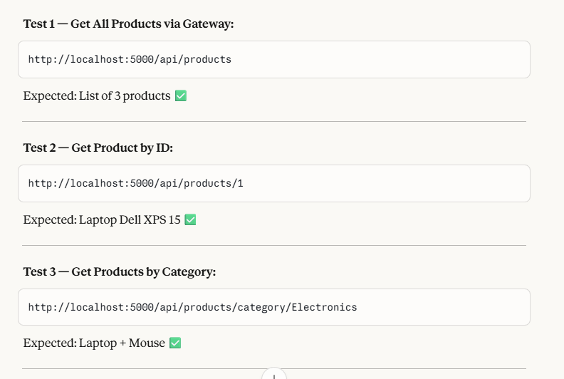

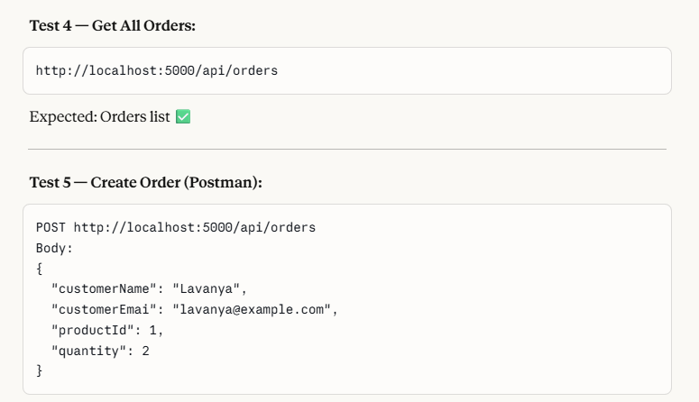

Expected –

✅ Order created
✅ RabbitMQ notification fired
✅ Kafka notification fired

In command prompt – open product api and give dotnet build and dotnet run and using postman you can check with the above endpoints for fetching the products
So here the difficulty is , you have to run each api separately, for each one you have to give dotnet build and dotnet run, this was the scenario which we did before docker compose , now after the docker compose ,we can give a single command “docker-compose up”
This docker-compose up starts everything ,that is it runs the Project container
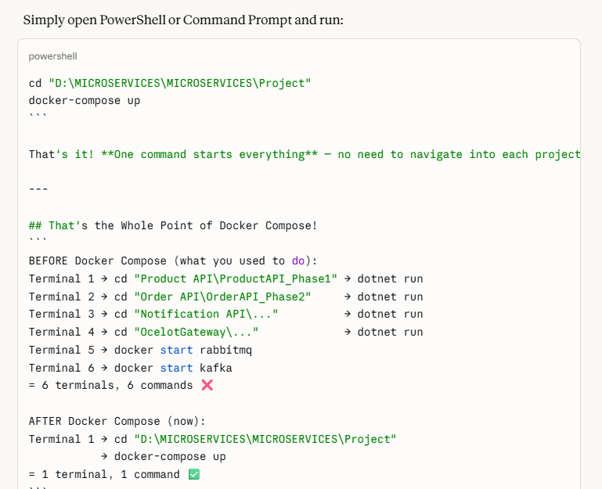

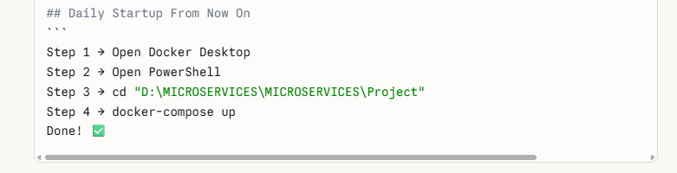

Important - In certain cases when you face conflict, you can use docker-compose down ,this will first remove the container running, stop the containers, etc. then you can give the docker compose up command which starts all the containers, if conflict arises do the following

- Docker-compose down
- Run docker-compose up –build
- Run docker-compose up (create fresh containers)

Always run docker-compose down before docker-compose up if you see conflict errors:

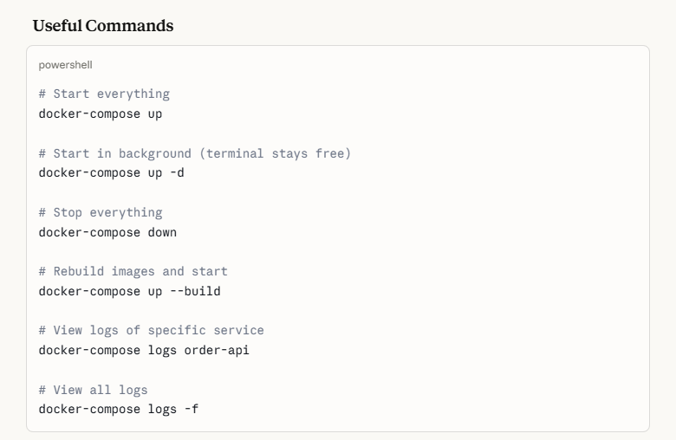

Docker-ps --- command for inspection to check what are the containers running
docker restart order-api --------- restarting the container

Important --- Now you can give docker -compose up and run the container, after this, using postman create an order and check whether the message is received in the kafka messagenger, if you face any error, check the ocelot gateway and ensure the following code snippet is included
Gateway- csproj
<Project Sdk="Microsoft.NET.Sdk.Web">

<PropertyGroup>
<TargetFramework>net9.0</TargetFramework>
<Nullable>enable</Nullable>
<ImplicitUsings>enable</ImplicitUsings>
</PropertyGroup>

<!--<ItemGroup>
<PackageReference Include="Microsoft.AspNetCore.OpenApi" Version="9.0.3" />
<PackageReference Include="Ocelot" Version="24.1.0" />
</ItemGroup>-->

<ItemGroup>
<None Update="ocelot.json">
<CopyToOutputDirectory>Always</CopyToOutputDirectory>
</None>
<None Update="ocelot.Docker.json">
<CopyToOutputDirectory>Always</CopyToOutputDirectory>
</None>
</ItemGroup>

</Project>

Docker Debugging — Quick Reference Notes

Issue 1 — Wrong Configuration Key
Error: BaseAddress = null → every HTTP request fails
Cause: Key name mismatch between Program.cs and appsettings.json
Program.cs reads: "ServiceUrls:ProductAPI"
appsettings.json has: "ProductAPI:BaseUrl" ← different!
Fix: Make all 3 match exactly
Program.cs → Configuration["ProductAPI:BaseUrl"]
appsettings.json → "ProductAPI": { "BaseUrl": "..." }
docker-compose.yml → ProductAPI__BaseUrl=http://product-api:8080
Where to check: Program.cs → AddHttpClient → Configuration key

Issue 2 — Polly Circuit Breaker Opens Too Early
Error: BrokenCircuitException / OnActionPreExecute
Cause: Product.API not ready at startup → Polly opens circuit → blocks all future requests even after Product.API is ready
Fix: Increase failures allowed + reduce break duration
Fix:
handledEventsAllowedBeforeBreaking: 10 // was 5
durationOfBreak: TimeSpan.FromSeconds(10) // was 30
Where to check: Program.cs → GetCircuitBreakerPolicy()

Issue 3 — RabbitMQ Not Ready at Startup
Error: BrokerUnreachableException / Connection refused 5672
Cause: Order.API starts before RabbitMQ fully initializes → crashes immediately
Fix: Add retry loop in RabbitMQMessageBus constructor
Fix:
for (int i = 0; i < 10; i++)
{
try { connect; break; }
catch { Thread.Sleep(5s); retry; }
}
Where to check: RabbitMQMessageBus.cs constructor + OrderCreatedConsumer.cs StartAsync

Issue 4 — MapOpenApi() Crashes in Production
Error: MapOpenApi not found / build fails in Docker
Cause: MapOpenApi() runs in Production but package missing
Fix: Wrap inside IsDevelopment() or remove completely
Fix:
if (app.Environment.IsDevelopment())
{
app.UseSwagger();
app.UseSwaggerUI();
// NO MapOpenApi() here
}
Where to check: Program.cs → search for MapOpenApi()

Issue 5 — docker-compose Changes Explained
What | Why
restart: on-failure | Auto restart crashed containers
ASPNETCORE_ENVIRONMENT=Production | Ensures correct config loads
healthcheck on RabbitMQ | Wait until truly ready
depends_on: service_healthy | Start after healthcheck passes

Quick Debugging Checklist
1. docker ps → all containers Up?
2. docker-compose logs service --tail 30 → what's the error?
3. Check config keys match (Program.cs = appsettings = docker-compose)
4. Check Polly circuit breaker settings
5. Check retry logic for RabbitMQ
6. docker-compose down → docker-compose up --build

Common Errors → Where to Look
Error | Check
BrokerUnreachableException | Retry in RabbitMQMessageBus.cs
Circuit breaker open | GetCircuitBreakerPolicy() in Program.cs
Name or service not known | Service names in ocelot.Docker.json
Connection refused | docker ps + environment variables
MapOpenApi not found | Remove from Program.cs or wrap in IsDevelopment
Config value null | Match keys in Program.cs + appsettings + docker-compose

Now when you post the orders in postman, you will get the message in the kafka broker

NEXT PHASE IS MOVING TO SQL SERVER AND EF CORE – PHASE 7 – REFER (PHASE 7 NOTES )

